Profile the following table in the Northwind Traders database. The first two have been done for you in

the previous part.

|  |  |  |  |  |
| --- | --- | --- | --- | --- |
| Table | Type | Row Count | PK Used | One row is |
| Employees | Master data | 9 | None (PK Used) | An employee |
| Employees territories | Business process | 49 | None (Pk Used) | An employee with an assigned territory. |
| Customers | Master data | 91 | Customer Id | A customer |
| Suppliers | Master data | 29 | None (PK used) | Supplier |
| Products | Master data | 77 | None (Pk Used) | Product |
| Shipments of orders | Business process | 3 | None (PK Used) | Shipment of an order |
| Details (of an order) | Business process | 2155 | OrderID, ProductID | Details of an order. |

Write SQL queries to answer the following questions that might be associated with functional business

requirements in a data warehouse. For each of the following provide a screenshot of the SQL query and

its output, making sure your name or NetID appears in the screenshot.

1. List the customer contact names and titles sorted by company name.

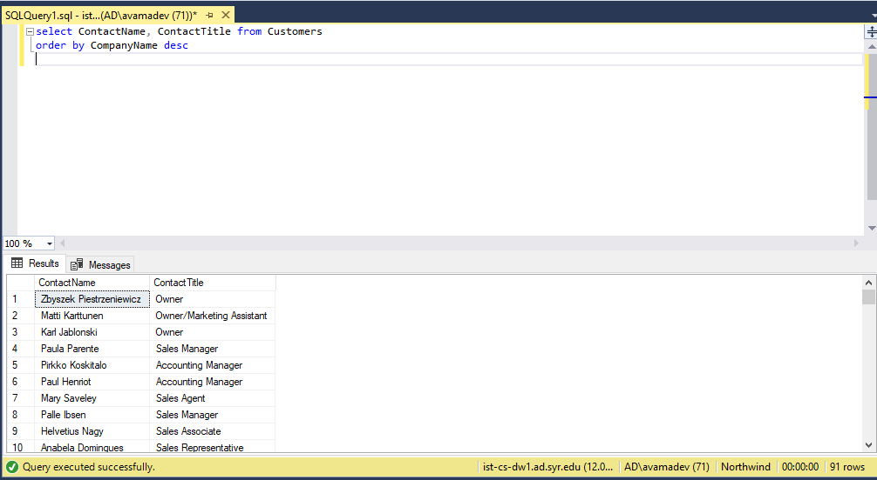

1. Factoring in discounts, what is total amount of product sold?

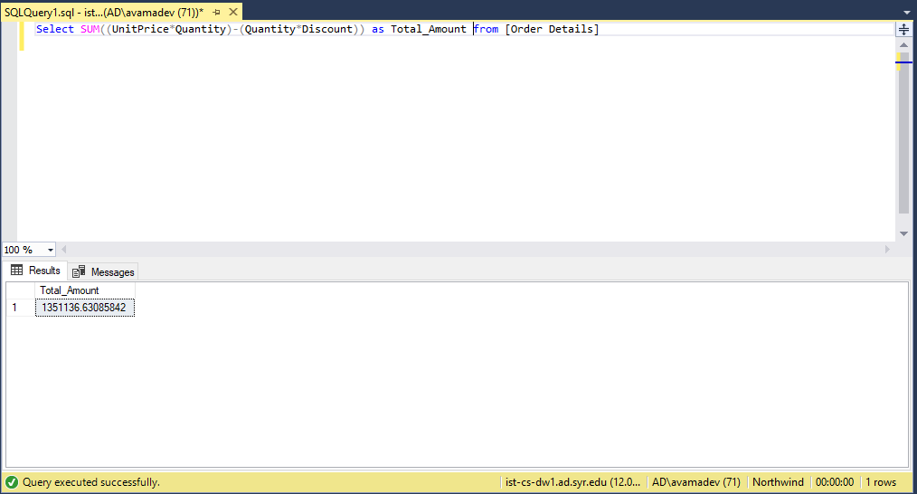

1. Provide a list of product category names with counts of products in each category.

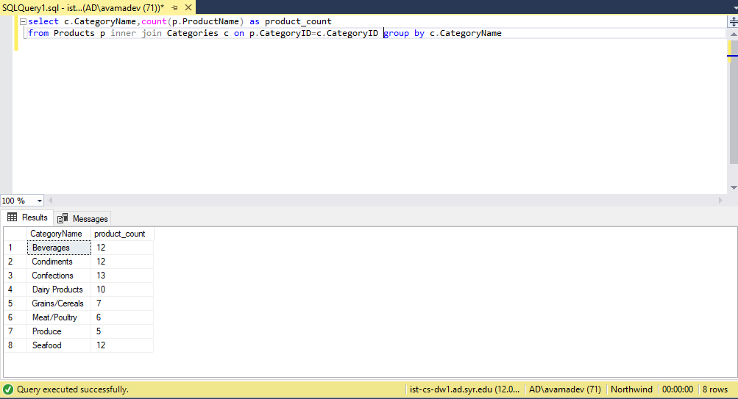

4. Select a specific customer, and display that customer’s orders with total amount of product sold

for each order.

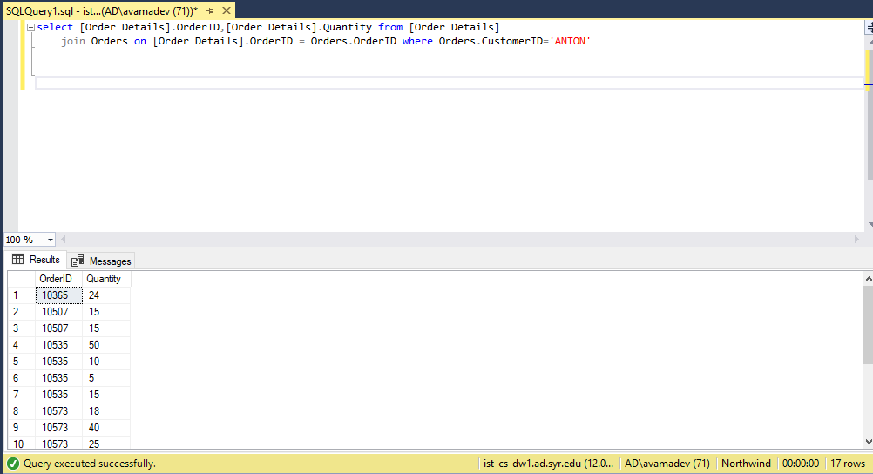

5. Select a specific employee and each order, how it was shipped (shipvia), the company who

shipped it, and the total number of days elapsed from order date to shipped date.

